Reading at Collingwood Primary School    Our Reading provision aims to develop a love of reading acquired through varied and enriching exposure to wide ranging texts, enabling pupils to broaden their knowledge of the world around them. | Content and Sequencing  Nursery – Enjoy rhyming and rhythmic activities and can join in with rhymes. They show awareness of rhyme and alliteration in books and spoken language. They begin to recognise initial sounds and develop oral blending and oracy skills.  Reception – Children demonstrate understanding of what has been read to them by retelling stories and narratives using their own words and recently introduced vocabulary, which they understand and use to discuss stories, non-fiction, rhymes and poems as well as during role play. They anticipate key events in stories. Children say a sound for letters of the alphabet and at least 10 digraphs. They read words consistent with their phonic knowledge by sound-blending. They read aloud simple sentences and books that are consistent with their phonic knowledge, including some common exception words.  Year 1 – Children can read speedily the correct GPC for all 40+ phonemes plus alternative sounds for graphemes. They read correctly most Year 1 common exception words. They read aloud books consistent with developing phonic knowledge and become familiar with key stories, beginning to make simple predictions.  Year 2 – Accurately read most words of two syllables. Read most words containing common suffixes and read most common exception words. They read books matched to phonics knowledge and children read fluently without any overt decoding. Pupils can answer questions and make some inferences.  Year 3 – Read and comprehend a range of texts at an age appropriate level. They continue to develop reading fluency and stamina. While reading aloud, they respond to a range of punctuation. They learn to summarise and draw inferences regarding character’s thoughts and motives. They identify how structure and presentation contribute to meaning.  Year 4 – Read and comprehend a range of texts at an age appropriate level. They continue to build reading stamina and fluency at a year 4 level. They read aloud, responding to a range of punctuation and begin to use contextual knowledge to understand the meaning of new vocabulary. Summarise key points in a chapter drawing inferences such as feelings, thoughts, motives and justify with evidence. They identify how structure and presentation contribute to meaning.  Year 5 – Read and comprehend a range of texts at an age appropriate level. They continue to build reading stamina and fluency at a year 5 level. They make comparisons within a text and read aloud with tone and intonation so the meaning is clear. They competently draw inferences from the text and justify with evidence, and they identify and evaluate an author’s choice of language, structure and presentation.  Year 6 - Read and comprehend a range of texts at an age appropriate level. They precis reading stamina and fluency at a year 6 level. They continue to read and discuss an increasingly wide range of texts that are structured for a variety of purposes and identify and discuss themes and conventions. They confidently draw inferences from the text and justify with evidence. Pupils discuss how author’s language, including figurative language, impacts on the reader. | Essentials  - Word reading – systematic phonics, learning GPC, developing skill of blending, reading common exception words, sharing high quality texts, developing fluency  - Comprehension – drawing on linguistic knowledge and knowledge of the world, read widely across a range of genres, develop a love of reading, increase pupils’ vocabulary, develop reading for pleasure, question what is read and what is inferred  - Making strong curriculum links – All pupils encouraged to read widely across both fiction and non-fiction to develop their knowledge of themselves and the world in which they live, to establish an appreciation and love of reading, and to gain knowledge across the curriculum.
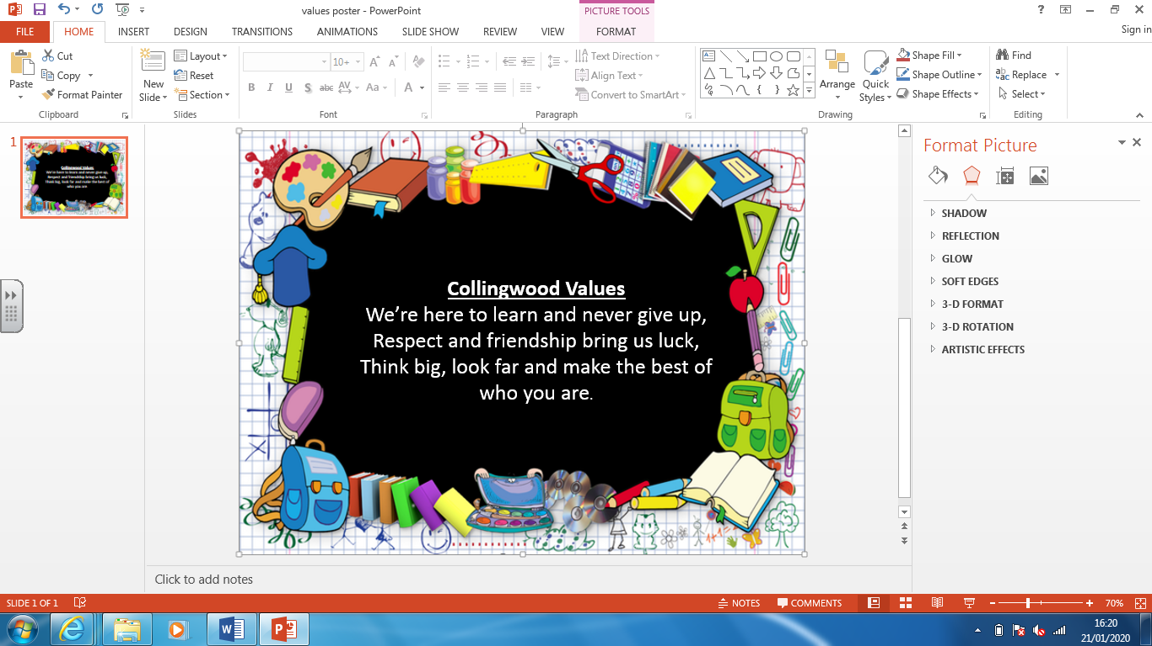

Progress
Units of work are carefully sequenced so prior knowledge and concepts are built upon.

Regular formative assessment and immediate feedback ensures gaps are filled.

Effective questioning and higher order thinking are embedded within all learning experiences.

Progress and attainment within units is recorded and shared with all teaching staff.

Opportunities for revisiting content or apply learning in greater depth. Key ideas, concepts and facts recorded in knowledge organisers.

