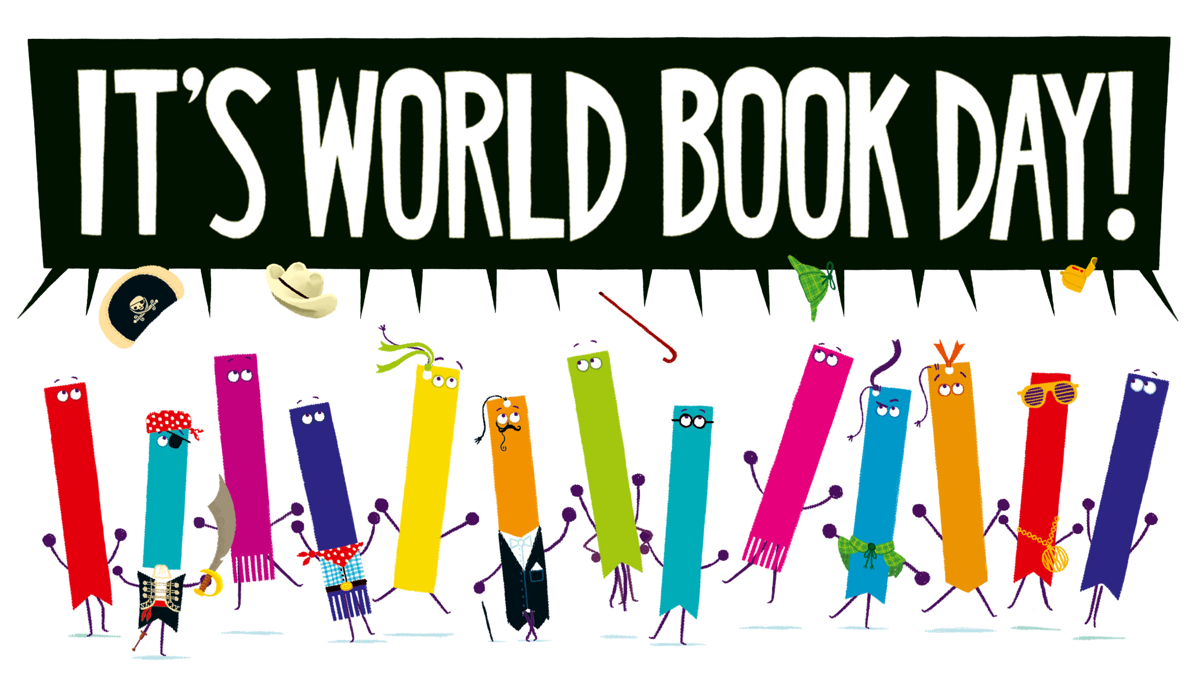
We are delighted to announce that Collingwood will be celebrating our love of books and reading again by holding our own World Book Day on
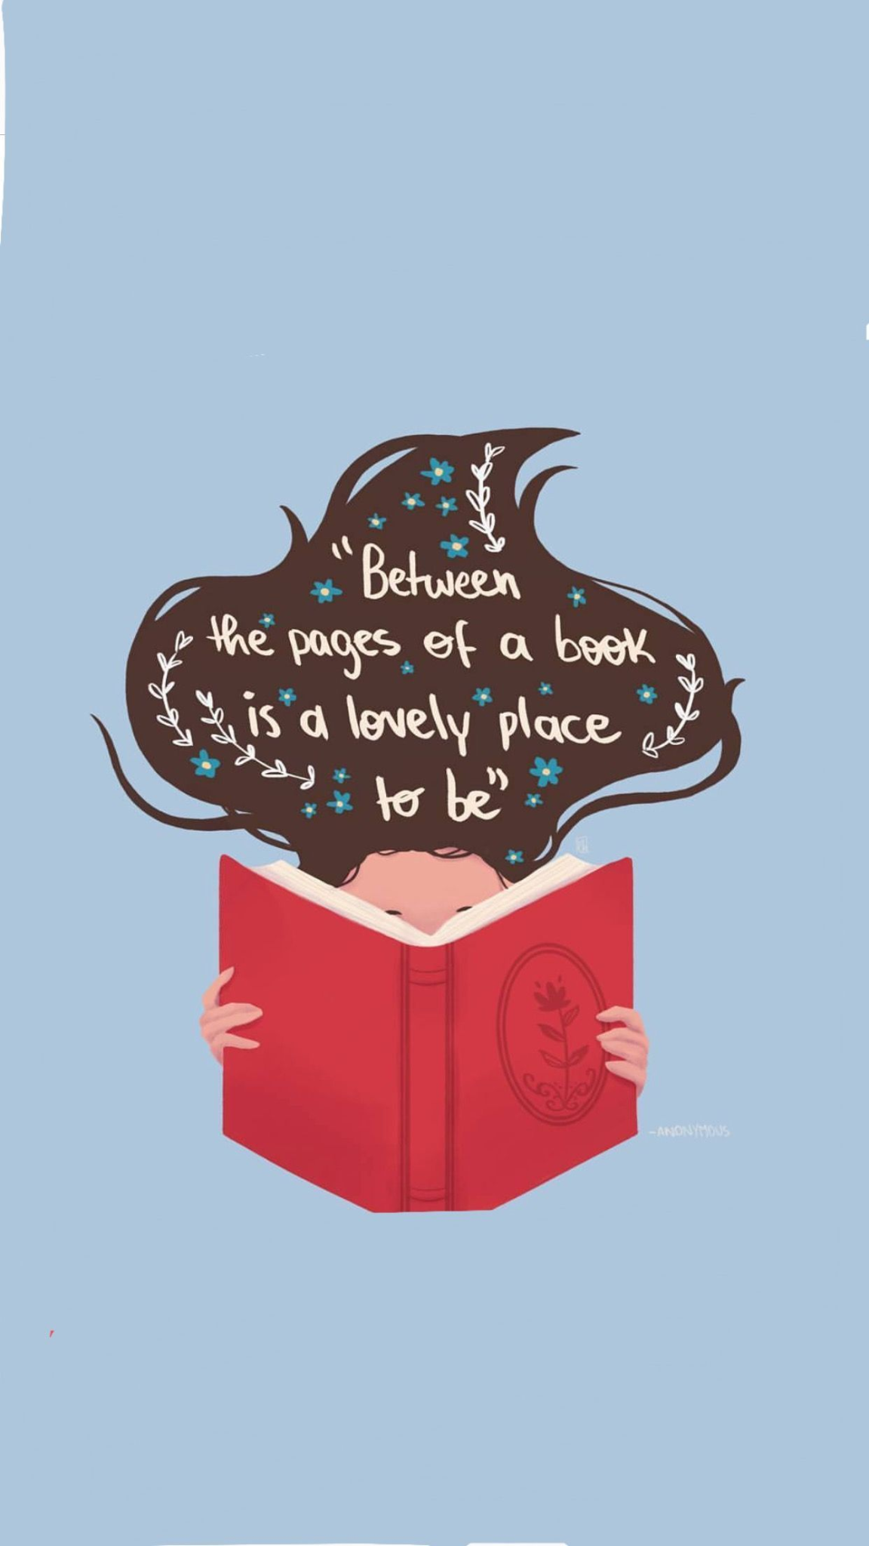
THURSDAY 5TH MARCH!
This year our theme is
READING FOR FUN!

Dress up day
As part of our celebrations we will be holding our annual dress up day where children can come to school as a character from a book OR as a representation of a word e.g. intelligent, dirty, sporty.

School Book Fayre
This year we will host our own book fayre across the week where children can buy a pre-loved book for mere pennies! We will also be selling pencils, rubbers and lots of other fun accessories at our fayre too. Further information to follow.

Costume swap shop
At Collingwood we are a community and we are always looking for ways to support our families, especially in current economic times. As a result, we would like to ask you to donate any old and unwanted dress up clothes into school or to our school office, allowing us to pass these onto some of our other families. Please pop to the office or call us during our first week back to see if there is a costume we would be able to offer you. We would welcome donations from Monday 9th February.

Potato competition
This competition has become a favourite amongst staff and children alike in the last two years. Children can decorate a potato linked to a book of their choice, at home, and bring it into see who will win the top prize! More details to follow on a separate letter.

Masked Reader
Back by popular demand…each day the children will receive a video sent to their class of a member of Collingwood staff reading them a story as a Masked Reader. Using their powers of deduction and a few clues thrown in to help, can they spot who is reading behind the mask?!
Exciting activities
Your children’s teachers have planned an exciting and engaging day, exploring their chosen text through reading, drama, art and much more! The jam-packed day will then culminate in a super show and tell assembly for children and staff on Friday 6th March where we get to share all the brilliant things we have all been up to.
Please see X/Twitter for lots of fantastic photos!

Book tokens
Watch out for the £1 book token your child will be bringing home, gifting them a fantastic choice of 12 books to choose from.

The fabulous books we’ll be exploring in school:

Year | Book | Author
Nursery | Cops and Robbers | Julia and Allan Ahlberg
Reception | Freddie and the Fairy | Julia Donaldson
Year 1 | That Rabbit Belongs to Emily Brown | Cressida Cowell
Year 2 | Wild | Cheryl Strayed
Year 3 | Leo and the Octopus | Isabelle Marinov
Year 4 | The Last Seaweed Pie | Wenda Shurety & Paddy Donnelly
Year 5 | Counting on Katherine | Helaine Becker
Year 6 | The Arrival | Shaun Tan
Did you know…?
This is the National Year of Reading 2026?

Reading reduces stress by 68%?

A child who reads for 20 minutes a day will be exposed to approximately 1.8 million words per year?

A child who reads for 5 minutes a day will be exposed to approximately 282,000 words per year?

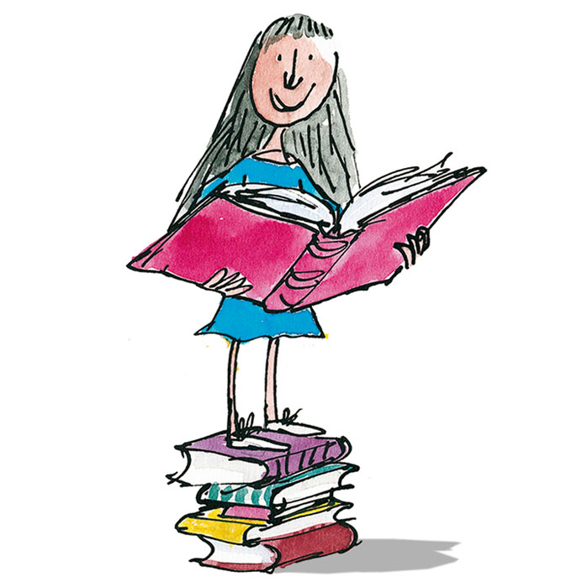
Not only is sharing a book with your child a bonding experience, it also helps open the gateway to the wider world, equipping them with the skills they will need to achieve in later life.
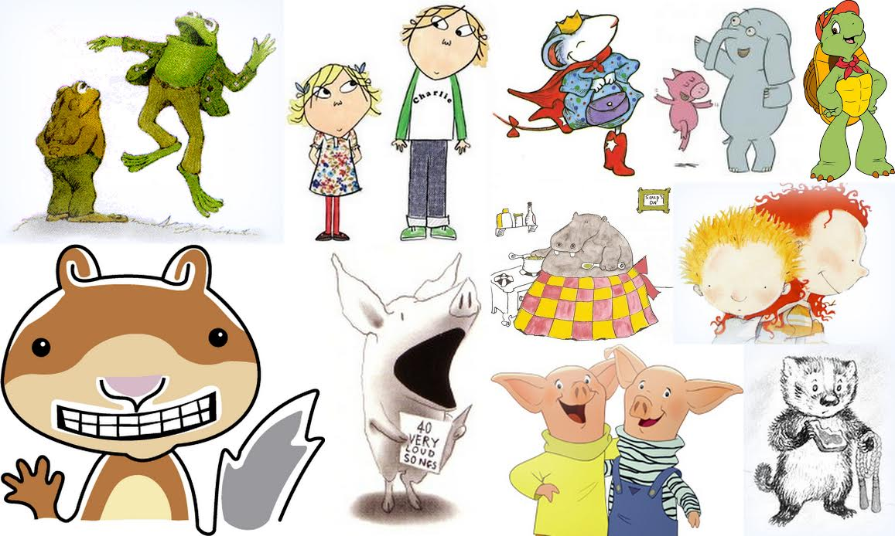
So let's get Collingwood reading!

