Retrieval Practice
- Low-stake quizzes for long term memory
- Varied teaching and learning activities
- Thoughtful sequencing of content
- Specific teaching of vocabulary

Content and Sequencing
EYFS: In EYFS, children begin their Art and Design journey through the specific area of Expressive Arts and Design. They are exposed to a wide range of different media, tools and techniques which allows them to explore and follow their own interests in a creative way. They develop their fine motor skills through drawing and mark-making, both indoors and outdoors. They have opportunities to carefully select, manipulate and combine materials to produce sculptures through junk modelling, explaining their choices for the materials chosen. Focus artists are introduced to inspire the children within their topics.
Year 1: Building upon Early Years creative skills pupils are taught to refine their drawing skills through creating patterns. They study the work of Picasso, exploring painting techniques, using thick and thin brushes and mixing colours to make tints and tones.
Year 2: Pupils are inspired by the work of Andy Warhol and Roy Lichenstein as the look at colour through Pop Art. They explore texture further to create a seaside collage. Pupils begin to look at sculpture, moulding and cutting techniques using clay.
Year 3: Pupils build upon and develop sculpture with clay, adding materials to provide detail. They begin to refine their drawing skills through fine sketching and shading. They are inspired by the movement of Stone Age cave paintings and look at the work of Richard Long.
Year 4: Pupils continue to develop their sketching and collage skills by looking at the work of Henri Rousseau; creating their own piece of natural art. They move on to exploring the work of the local artist John Coatsworth, exploring with paint and colour to create different moods.
Year 5: Pupils continue to develop a personal style of sketching and painting skills choosing to look at the post impressionism work of Van Gogh. Creating texture and enhancing mood. They also carve sculptures and use digital media to create a piece of artwork in Summer.
Year 6: Pupils develop their drawing skills by using a choice of techniques that depict movement, perspective, shadows and reflection. They do this through the work of Hans Holbien and portraits. They also use frames or moulds to sculpture and choose from a wide range of stitching techniques to create a piece in summer term.

Art and Design at Collingwood Primary School: Our Art and Design curriculum endeavours to develop creativity, set challenges, engage and inspire learners. It gives pupils the opportunity to learn about and take inspiration from artists of past and present. Using different materials and techniques they are encouraged to be creative, confident and original in the work that they produce whilst recording their ideas and observations in sketch books.

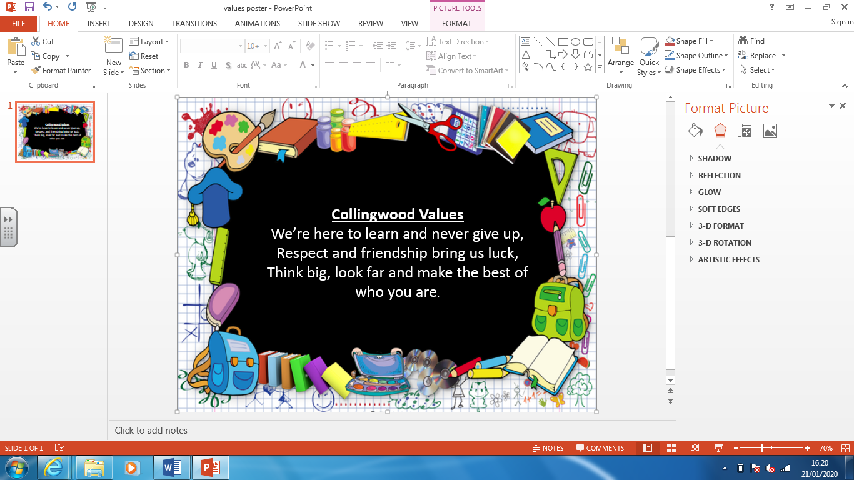
Essentials
• The ability to use visual language skillfully and convincingly to express emotions, interpret observations,
convey insights and accentuate their individuality.
• The ability to communicate fluently in visual and tactile form.
• The ability to draw confidently and adventurously from observation, memory and imagination.
• The ability to explore and invent marks, develop and deconstruct ideas and communicate perceptively and powerfully through purposeful drawing in 2D, 3D or digital media.
• An impressive knowledge and understanding of other artists, craftmakers and designers.
• The ability to think and act like creative practitioners by using their knowledge and understanding to inform, inspire and interpret ideas, observations and feelings.
• Independence, initiative and originality which they can use to develop their creativity.
• The ability to select and use materials, processes and techniques skillfully and inventively to realise intentions and capitalise on the unexpected.
• The ability to reflect on, analyse and critically evaluate their own work and that of others.
• A passion for and a commitment to the subject.

Progress
Units of work are carefully sequenced so prior knowledge and concepts are built upon.
Regular formative assessment and immediate feedback ensures gaps are filled.
Effective questioning and higher order thinking are embedded within all learning experiences.
Progress and attainment within units is recorded and shared with all teaching staff.
Opportunities for revisiting content or apply learning in greater depth. Key ideas, concepts and facts recorded in knowledge organisers.

