Content and Sequencing
EYFS- In EYFS, children begin their Design and Technology journey through the physical development of fine motor skills; learning how to use and manipulate simple tools, including woodwork tools and begin joining materials safely. They are exposed to and use different food preparation tools under supervision. Through Expressive Arts and Design children select materials to incorporate into design, explaining their choices for the materials chosen.
Year 1: Year 1 begin to look at structures within their local area, demonstrating how to use a range of joining techniques to strengthen the materials they use. They will then begin to explore existing products in detail, using these to produce their own moving mechanism. Developing their fine motor skills further, year 1 children begin to shape textiles and decorate using dying techniques. In food and nutrition children begin to cut, peel and grate ingredients to promote healthy eating choices into their lives.
Year 2: Pupils build upon their developing knowledge by joining textiles using a running stitch. They suggest improvements to existing designs and explore different decorative techniques, as well as developing their understanding of mechanisms by building a product with wheels, axels and levers. Simple software is used to support the design process. They prepare, assemble and cook ingredients to make bread.
Year 3: Building upon their skills from KS1, children are encouraged to select appropriate techniques to use to sew a seam and decorate a textile. They select tools and techniques; begin to add slots and cuts to their models, measuring to the nearest millimetre. Children use their scientific knowledge of forces to choose mechanisms for their product. From looking at work from great designers they begin to look at how products can be repaired and refined and use software (LegoWeDo) to control and monitor products. Pupils revisit KS1 skills of preparing, assembling and cooking food.
Year 4: Children continue utilising the skills they have been taught and acquired in Year 3 and KS1 and apply these to textiles and materials. Children create series and parallel circuits in electronics. They continue to develop their cooking skills, following a recipe to cook soup, controlling temperature and measuring to the nearest gram.
Year 5: Children create innovative designs that improve upon existing products and evaluate the design of products so as to suggest improvements to the user experience, their understanding of mechanics is improved by using rotary motion in cams. Children continue to use computing to code and control motion and build upon their electronic skills from Year 4. In food and nutrition children look at the elements of a salad and preparing and cooking fish from the local Fish Quay.
Year 6: Children continue to be inspired by designers, improving and creating innovative products. They make products using prototypes through computer aided designs, as well as previously gained skills and create electronic circuits that employ a number of components. Children write code to control and monitor models or products using MicroBit. They choose from a range of joining techniques in textiles that employ seam allowance and use their knowledge of the qualities of materials to choose suitable decoration. Their food nutrition allows them to explore cooking and baking, and make links to rationing in WW2.

DT at Collingwood Primary School: Our DT curriculum enables children to take creative risks in the designing and manufacturing of products. Through using a variety of knowledge, skills and equipment they will be able to innovate their ideas and promote a passion for the development of our ever changing world.

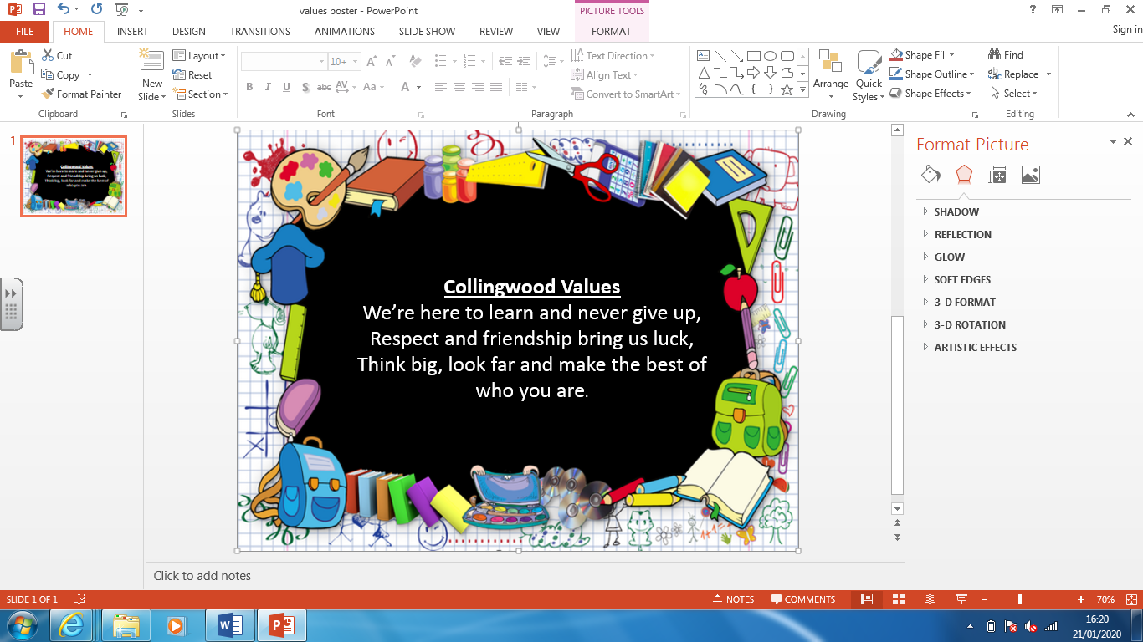
Essentials
• Significant levels of originality and the willingness to take creative risks to produce innovative ideas and prototypes.
• An excellent attitude to learning and independent working.
• The ability to use time efficiently and work constructively and productively with others.
• The ability to carry out thorough research, show initiative and ask questions to develop an exceptionally detailed knowledge of users’ needs.
• The ability to act as responsible designers and makers, working ethically, using finite materials carefully and working safely.
• A thorough knowledge of which tools, equipment and materials to use to make their products.
• The ability to apply mathematical knowledge.
• The ability to manage risks exceptionally well to manufacture products safely and hygienically.
• A passion for the subject and knowledge of, up-to-date technological innovations in materials, products and systems

Progress
Units of work are carefully sequenced so prior knowledge and concepts are built upon.
Regular formative assessment and immediate feedback ensures gaps are filled.
Effective questioning and higher order thinking are embedded within all learning experiences.
Progress and attainment within units is recorded and shared with all teaching staff.
Opportunities for revisiting content or apply learning in greater depth. Key ideas, concepts and facts recorded in knowledge organisers.

Retrieval Practise
Varied teaching, learning and practical activities
Specific teaching of vocabulary
Vocabulary build up across year groups and key stages

