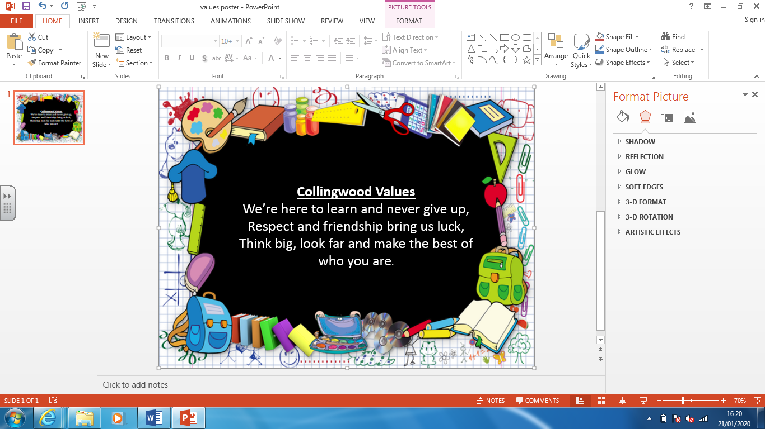
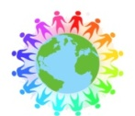
Retrieval Practice
Knowledge organisers made available to children
Low-stake quizzes for long term memory
Varied teaching and learning activities
Thoughtful sequencing of content
Specific teaching of vocabulary

Essentials
An excellent knowledge of where places are and what they are like.

An excellent understanding of the ways in which places are interdependent and interconnected and how much human and physical environments are interrelated.

An extensive base of geographical knowledge and vocabulary.

Fluency in complex, geographical enquiry and the ability to apply questioning skills and use effective analytical and presentational techniques.

The ability to reach clear conclusions and develop a reasoned argument to explain findings.

Significant levels of originality, imagination or creativity as shown in interpretations and representations of the subject matter.

Highly developed and frequently utilised fieldwork and other geographical skills and techniques.

A passion for and commitment to the subject, and a real sense of curiosity to find out about the world and the people who live there.

The ability to express well-balanced opinions, rooted in very good knowledge and understanding about current and contemporary issues in society and the environment.

Progress
Units of work are carefully sequenced so prior knowledge and concepts are built upon.
Regular formative assessment and immediate feedback ensures gaps are filled.
Effective questioning and higher order thinking are embedded within all learning experiences.
Progress and attainment within units is recorded and shared with all teaching staff.
Opportunities for revisiting content or apply learning in greater depth. Key ideas, concepts and facts recorded in knowledge organisers.

Curriculum Drivers

Geography at Collingwood Primary School
Our Geography curriculum aims to encourage a lifelong passion for environments, both human and physical, and inspire a curious and inquisitive mind about the world we are all part of.

Content and Sequencing
EYFS In EYFS the children begin by exploring and learning about our planet with their ‘Around the World’ topic. Following on from their comparison of places around the world, the children focus on a continent with ‘African Safari’. The children explore oceans during ‘Under the sea’ and combine this with our local area whilst studying ‘Beside the seaside’.
Year 1 In Year 1 ‘Wonderful World’ builds on from the EYFS curriculum. There is their first engagement with world maps looking at hot and cold countries. ‘Beside The Seaside’ continues to focus on our local area study of the coast and North Shields.
Year 2 Year 2 build wider understanding of where we live with the topic ‘How do we become our own hero?’ The children work to solidify knowledge of the world map by focussing on continents and oceans before doing a depth study of the Antarctica and a variety of weathers in ‘Frozen World’.
Year 3 Year 3 moves onto considering more details features of the world map identifying climate and biomes which will be features which will be looked at again in ‘Tremors, Volcanoes and Earthquakes: Natural Disasters’.
Year 4 To enhance their knowledge on the world and the occurrences around us, the children complete a ‘Save Our Planet’ topic, covering global warming, rainforests, and ice caps. They carry on with local geography during ‘Pride Of Place’.
Year 5 Expanding on their prior knowledge of the world, Year 5 look at space and the world beyond planet Earth in ‘Extreme Explorers’ They then deepen their understanding of seas and oceans during ‘Coastlines and The North East’
Year 6 Continuing with their understanding of the continents and oceans Year 6 study ‘The Titanic’ and ‘Oceans’. This makes link with recycling, climate zones, trading. They make comparisons when completing the topic ‘South America’ looking at human geography, distribution of natural resources, tribes and hunting and poaching.

