Content and Sequencing
EYFS During their time in EYFS children talk about their lives, past memories and celebrate traditions and events . Through exploring topics such as All about me, My family Tree and Me, Childhood now and then- Betrix Potter and exposure to well chosen texts, the children are able to develop an understanding of the passing of time and similarities and differences between things in the past and now. The children are provided with a language rich environment which allows them to build their vocabulary and understanding of the world around them in preparation for learning in Y1.
Year 1 begin with a look at their family and changes in their life. This helps to build upon their vocabulary they have begun to develop at EYFS and their concept of time. They move onto looking at significant people and events around Space travel. Finally they look at the changes and developments of the local seaside. asking and answering simple questions, drawing comparisons and understanding change over time.
Year 2 look at a significant event in British History the Great Fire of London and begin to understand cause and effect. They move on to look at the exploration of the Antarctica by looking into the expedition and the key inspirational figures. Finally, they look at a significant local people and places by comparing the differences between Castle life now and then. Children build understanding of chronology and change.
Year 3 begin by understanding the concept of Ancient Egypt and consider evidence left behind. Next they study the concept of pre-history by looking at Stone Age and Iron Age Britain and considering how we learnt about these periods.
Year 4 study an Amazonian Tribe while studying the Rainforests in geography. They then concentrate on our local area by studying significant people, places and events in Tyneside. This is followed by more local history taught through an in-depth study of The Roman Empire and its impact on Britain.
Year 5 study an Ancient civilisation; Greece. Through
this pupils find out how life in other parts of the world have affected us today. This is followed by a look at a range of Explorers on land and in Space. They then return to look at how Britain was affected by invasions by considering life in Anglo-Saxon Britain and considering the Viking Invasion and Anglo-Saxon struggle.
Year 6 begin by studying the Tudors with focus on the Monarchy, Crime and its impact on today’s society. Next they use evidence and a range of sources to research the key events of the Titanic tragedy and the social hierarchy during this period. This provides children with time for reflection and evaluation of past events. Through a Geography unit they look at South America and discover differences with Non-European society. Finally, they study a significant turning point in Britain through their WW2 study where pupils consider a variety of sources and viewpoints. They look at the battle of Britain to consider how life in Britain was impacted.

Essentials
An excellent knowledge and understanding of people, events from a range of historical periods.
To consistently support, evaluate and challenge their own and others’ views using different sources.
To think, reflect, debate, discuss and evaluate the past, formulating and refining questions and lines of enquiry.
A passion for history and an enthusiastic engagement in learning, which helps to understand how and why people interpret the past in different ways.
A respect for historical evidence and the ability to make critical use of it to support their explanations.
A desire to embrace challenging activities.
Progress
Units of work are carefully sequenced so prior knowledge and concepts are built upon.
Regular formative assessment and immediate feedback ensures gaps are filled.
Effective questioning and higher order thinking are embedded within all learning experiences.
Progress and attainment within units is recorded and shared with all teaching staff.
Opportunities for revisiting content or apply learning in greater depth. Key ideas, concepts and facts recorded in knowledge organisers.

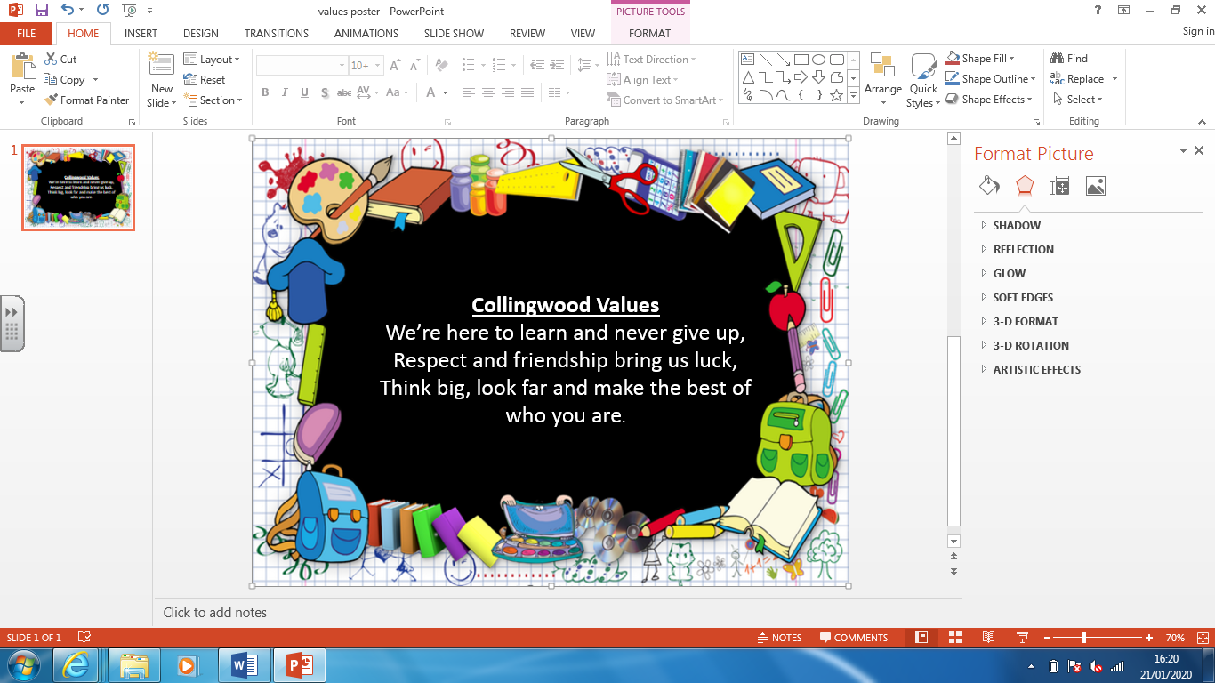
Retrieval Practice
- Knowledge organisers made available to children
- Low-stake quizzes for long term memory
- Varied teaching and learning activities
- Thoughtful sequencing of content
- Specific teaching of vocabulary

History at Collingwood Primary School. Our History provision aims to create enthusiasm, passion and curiosity about the past, present and people who have changed our World.



