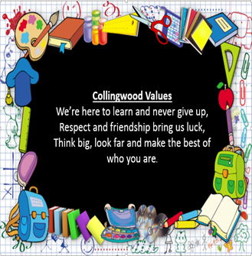
Content and Sequencing
Year 3 start to learn basic greetings and classroom instructions in French as well as extra vocabulary including numbers, colours and animals. They also discover facts about France and its culture. They are taught to identify sounds in words, rhymes and songs and respond to single words and familiar, short phrases. They present simple, personal information, both orally and in writing.
Year 4 continue to build on their French knowledge by learning to introduce themselves and others, discuss feelings and count up to 20. They take part in role plays to ask and answer a range of simple familiar questions. They express likes and dislikes and try to understand the opinions of others. They learn about countries and towns in Europe.
Year 5 begin to understand the main points of short texts. They learn to express and justify opinions and ask the opinion of others. Their phonic knowledge is expanded to enable their pronunciation of unfamiliar words and they use intonation with increasing accuracy when reading aloud. They also copy and adapt longer sentences using a writing frame, with some writing more independently using bilingual dictionaries. Their increased knowledge of grammar is reflected in their sentence structure and spelling.

Year 6 produce oral and written work that demonstrates increasing grammatical understanding. They have the opportunity to give spoken presentations using longer sentences and answer simple questions about them. They learn about other French-speaking countries and practise offering polite requests and instructions within the context of different cultural contexts. They learn to read, analyse and decode texts, identifying word classes and making inferences based on textual evidence. They are encouraged to write and redraft paragraphs independently, using a range of simple and complex sentences and with the help of glossaries, bilingual dictionaries or online tools.

Languages at Collingwood Primary School we prepare children to be part of a global society by instilling in them a passion for language learning and by promoting awareness of other countries and cultures as well as their own.

Curriculum Drivers

Retrieval Practice
Regular French register activities
Flashcard/prop games
Vocabulary challenges
Knowledge organisers/displays
Pair work/peer assessment
End-of-unit self-assessment

Progress
Units of work are carefully sequenced so prior knowledge and concepts are built upon.
Regular formative assessment and immediate feedback ensures gaps are filled.
Effective questioning and higher order thinking are embedded within all learning experiences.
Progress and attainment within units is recorded and shared with all teaching staff.
Opportunities for revisiting content or apply learning in greater depth. Key ideas, concepts and facts recorded in knowledge organisers.

Essentials
The confidence to speak with good intonation and pronunciation.
Fluency in reading.
Fluency and imagination in writing.
A strong awareness of the culture of the countries where the language is spoken.
A passion for languages and a commitment to the subject.
The ability to use language creatively and spontaneously.
An independence in their studies and the ability to draw upon a wide range of resources.


