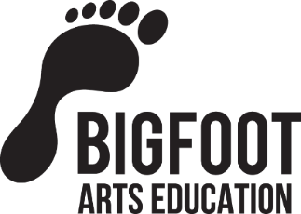
HAF Provider Impact Report
Bigfoot’s Summer Creative Burst at Collingwood Primary 2024

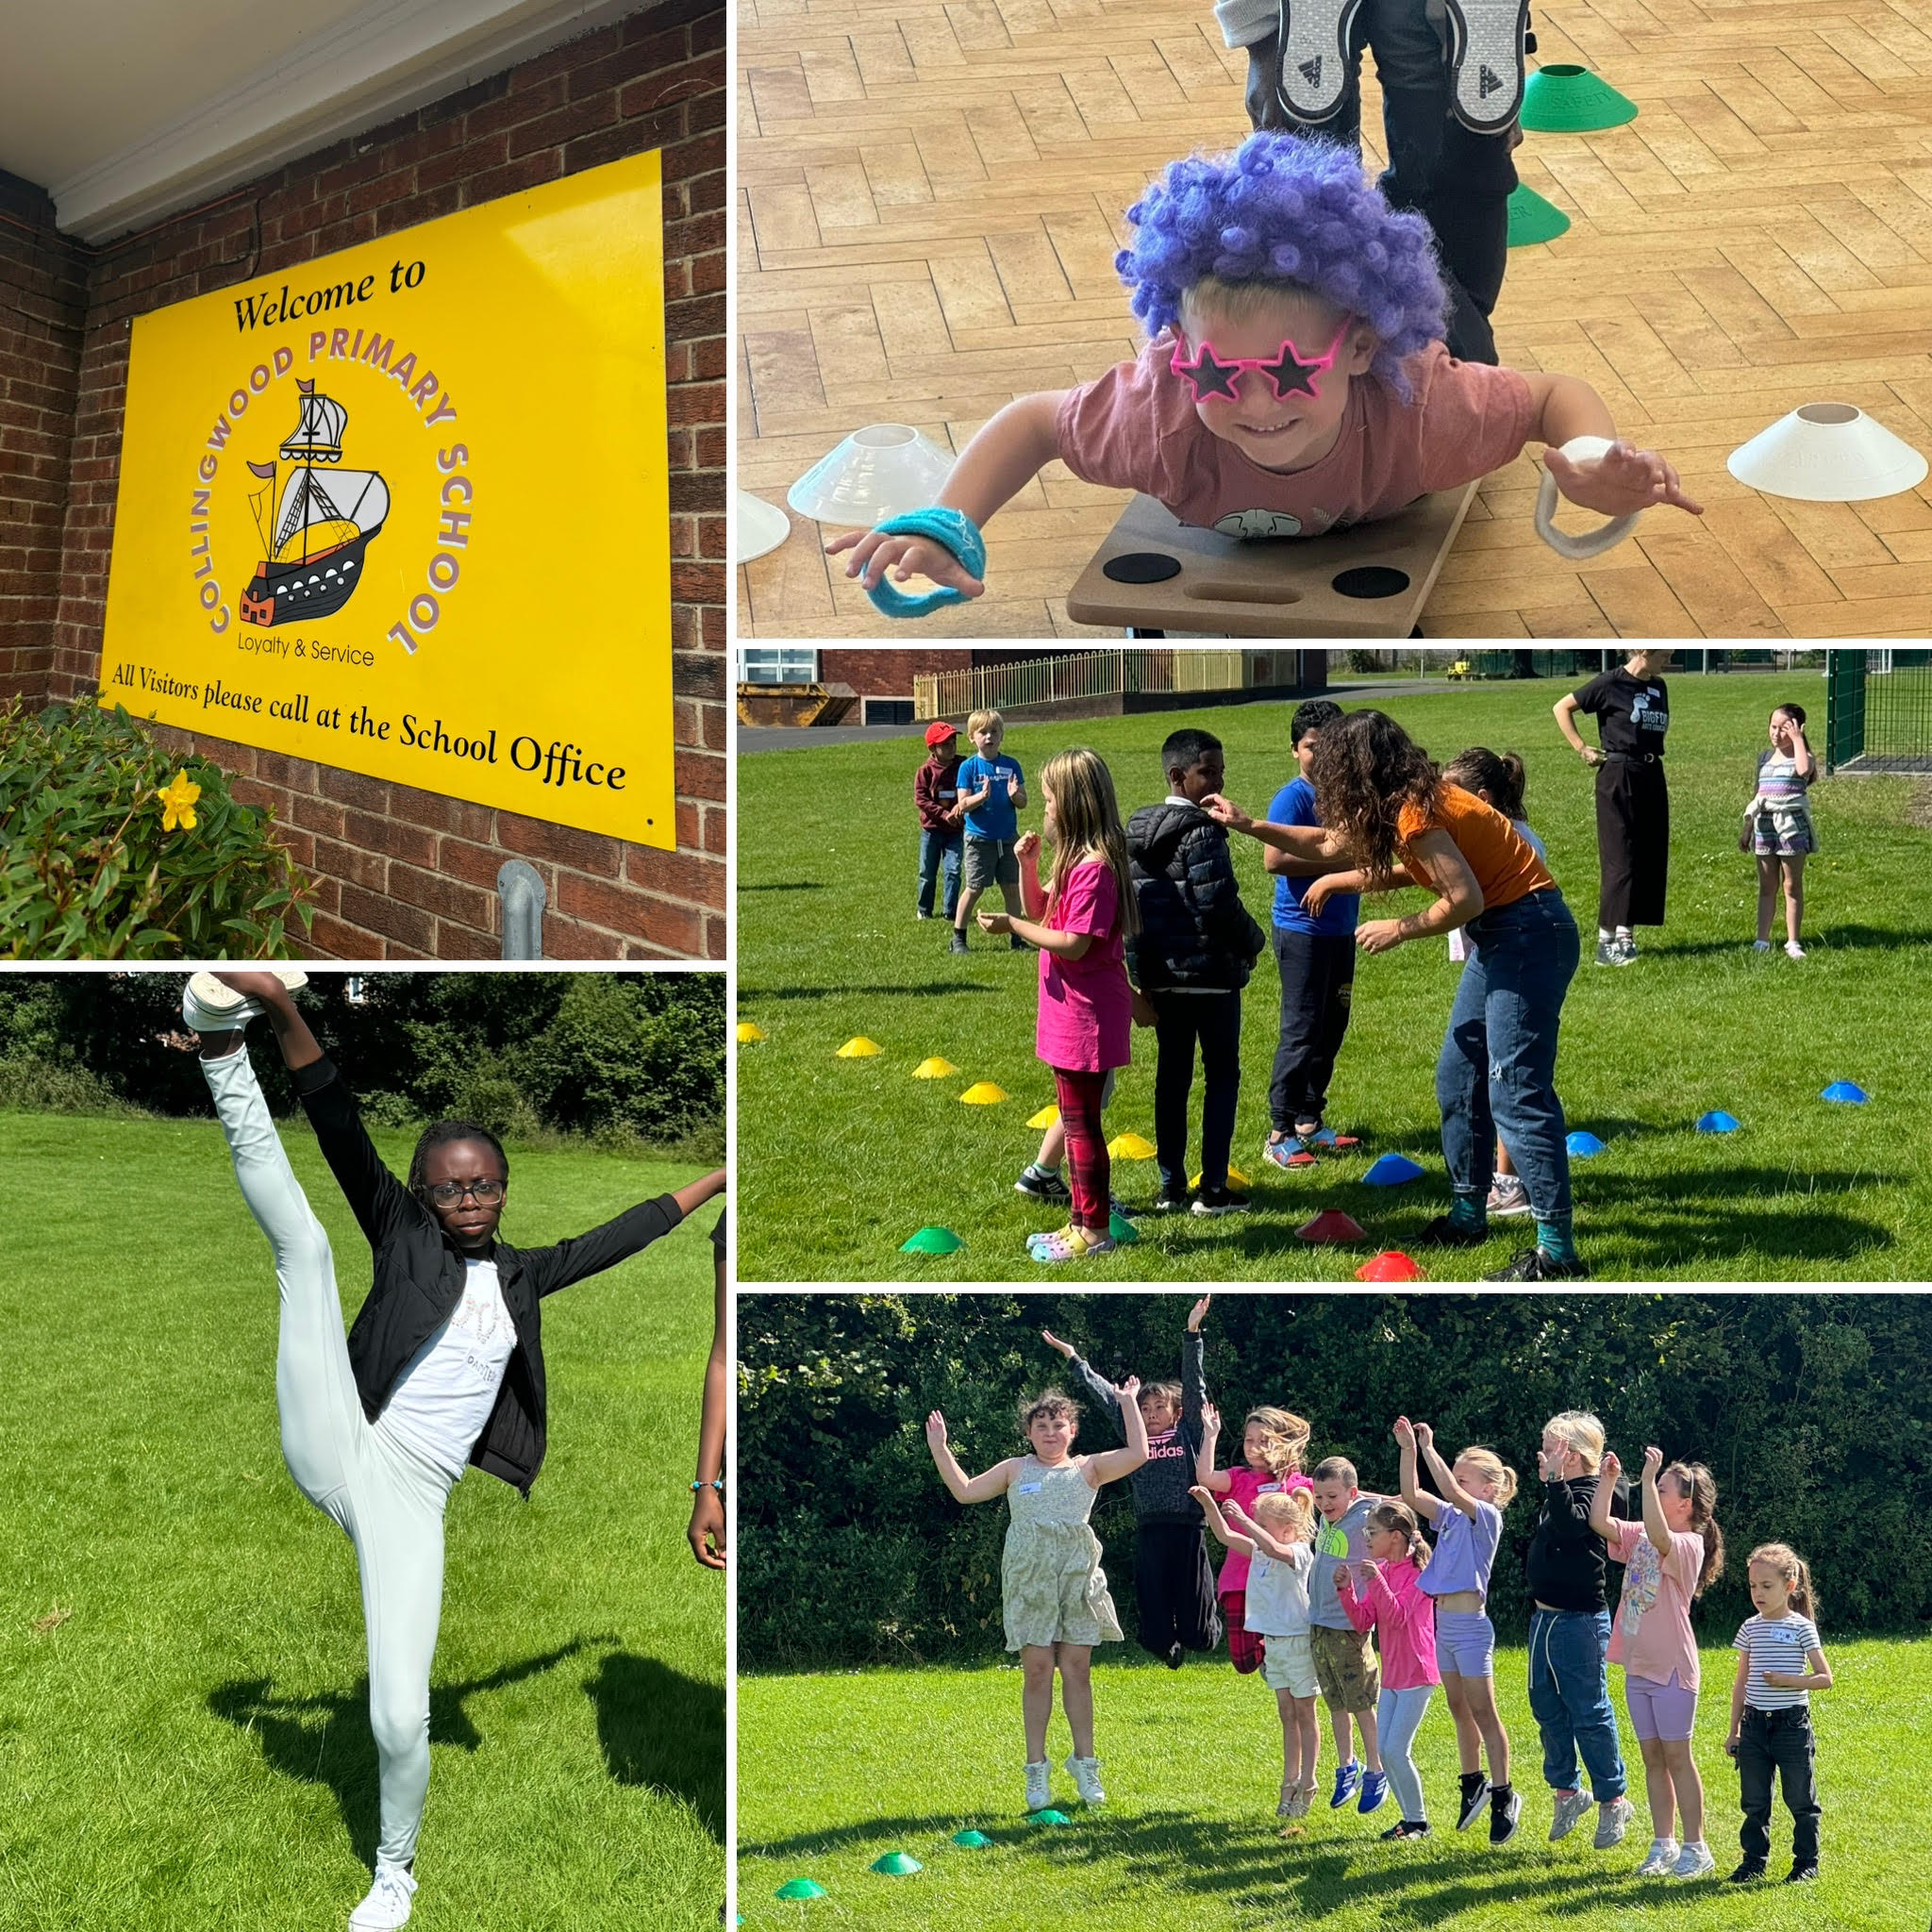
Overview of provision
Bigfoot’s Summer Creative Burst at Collingwood Primary delivered four consecutive weeks of drama, theatre making, arts and crafts and food education across the Summer Holidays. With the Olympic Games in Paris happening this Summer, we gave our club an Olympic theme which celebrated their core values of Excellence, Respect and Friendship.
Lunches each day were provided by Scott’s Catering which is a local catering company and established provider of HAF meals. They worked with us to design a menu which we felt was appealing to our young people as well as provided good nutrition to fuel the young people throughout the days. We also partnered with Morrisons in North Shields who provided fresh fruit, vegetables, bread, cordial juice and cereal bars so the young people had lots of healthy snack options during their breaks.
Each week the young people took part in a range of activities which celebrated how being active and creative is of huge benefit wellbeing, and promoted healthy eating in order to feel well and fuel our bodies just as professional athletes and performers do!
Through the support of the school admin team we were able to communicate the club amongst parents, enabling us to reach those who were most in need of HAF provision over the Holidays. We received positive feedback from parents that our clubs reduced their stress and anxieties over feeding the children during the holidays and that the young people felt lots of positive emotion and achievement from attending.
Marketing and registration – How did you reach the participants and families?
The school office publicised the summer holiday camp over summer term by sending out emails to all parents and carers, promoting the summer camp with parents over the phone and face to face. The school office also worked with teaching staff to identify children who would particularly benefit from attending the summer camp. In addition, a member of the school office staff manned a stall at the school summer fair with the HAF team and proactively helped parents to sign their children up. It was great to see children from many families attending the over the summer. The camp provided a welcome and much needed entertainment for the children.
Attendance
There were a total number of 595 session attendees over the 4 week summer camp. Children from Reception to Year 6 took part in Bigfoot’s Summer Creative Burst and NUFC Multi-skills clubs.
Note from Bigfoot: Due to unrest following the events in Southport, many families from Black, Asian and Eastern European communities decided they did not want to send their children out of their homes to come to the clubs. Understandably, families reported that they did not feel safe being out in public in North Tyneside whilst rioting and racially motivated aggression was breaking out across the area. During this time, we stepped up our efforts to reach them as we feel strongly that they must receive the message that they are welcome and cared for.

Food and nutritional education
We worked with a local catering company – Scott’s Catering – who provided healthy meal options each day. All the children reported that they thoroughly enjoyed the food with many taking any left overs home for their evening meals. We reached out to Morrisons in North Shields and partnered with their Community Champion who donated fresh fruit, vegetables, healthy cereal bars, bread and fresh juice which the children snacked on throughout the week.

EXAMPLE MENU:
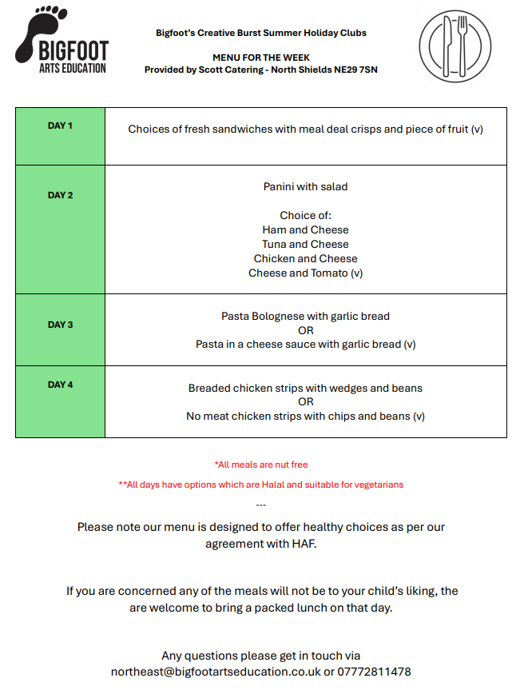
Physical activities
Each day was packed with physical activity both inside and outside in the school playground. All children who completed evaluation forms reported that they were moving for at least 1 hour of the day. The physical activity undertaken by the children took the form of high-energy drama games, dancing, performing and doing team Olympic sports such as relay races and gymnastic routines.
Enriching activities, wider impacts and case studies
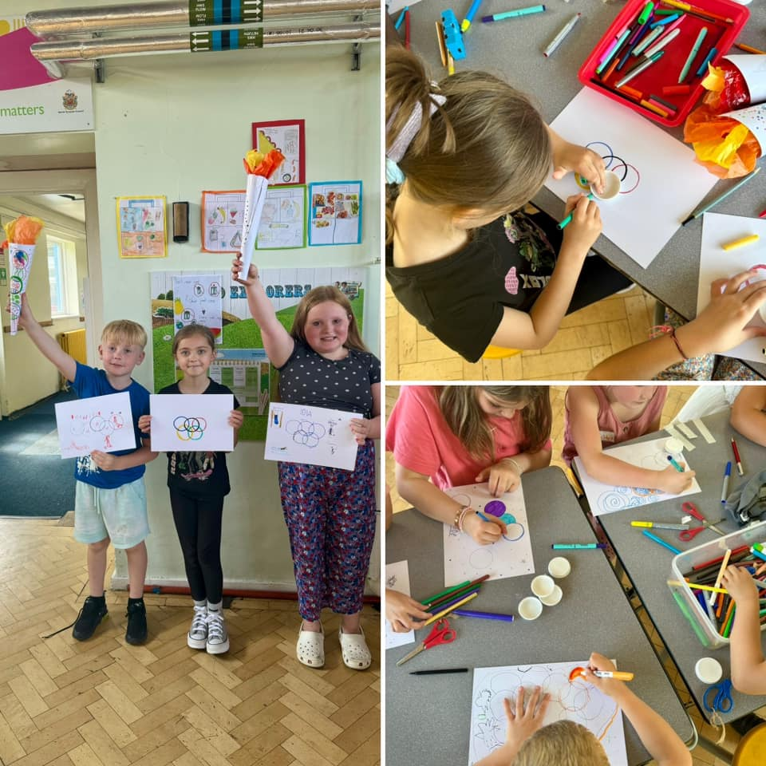
Bigfoot’s Easter Summer Burst provided opportunities for the attendees to try new things and learn a range of new skills. From performance to creative crafts to Olympic sports, the children explored and developed their artistic and expressive abilities. Throughout the 4 weeks, the young people worked in teams to collect points for good listening, teamwork, creativity, and positive attitude and on the final day the winning team was rewarded with a small prize. We deliberately put the children in groups with others who they did not know very well, to nurture new friendships and this was a success as most children who completed an evaluation forms reported they had made at new friends.
Confidence was built by staging a show back event on the final day of each club, where they performed shared with their grown-ups the activities they’d taken part in and skills learnt.

Signposting – What steps were taken to signpost and provide further support to families during the school holidays?
There was no requirement or need to signpost and provide further support to families during the school holidays. Collingwood Primary School have a Family Support Worker who kept in touch with families who may have required support over the summer.

Next steps
In summary the summer camp at Collingwood Primary School was a great success. Alongside the Bigfoot Provision, the school also arranged for an NUFC multi-sports camp to run for 2 weeks from Monday to Friday. This was supported by school staff and was well attended by all children who thoroughly enjoyed the range of multi-sports including football basketball, cricket and rounders. All staff were welcoming and friendly, there were well prepared activities for the children each day with a good mix of indoor and outdoor sessions. The parents were delighted with the provision and particularly enjoyed the end of week performances which the children also really enjoyed. The Summer Holiday Camp was a great success and we hope to hold another HAF camp at Collingwood next year. Here is some parental feedback on the summer camp:
“Absolutely fantastic. Has kept him very happy and entertained….and the fact that he also received a healthy filling lunch has been a real positive. He loves these clubs and has already mentioned coming back next year.”
“Staff are lovely. Kids loved them and came back everyday saying they loved the activities they had done.”
“I hope the summer club continues as it is a great help for families especially keeping children entertained while parents go to work.”
“Thank you, you have all done a great job”
“Building up confidence, plus gain new friendships”
“Great effort from all the staff involved. The kids have really enjoyed themselves.”

Areas we’d like to improve and ideas for future programmes
The IT system for booking children onto the HAF summer holiday clubs could be greatly improved. The requirement to apply for ‘eligible’ or ‘non-eligible’ places was confusing for parents and discouraged some families from applying for the summer holiday club. The HAF team approved all ‘non eligible’ bookings for Collingwood however this was a time consuming process.

.

Photographs from Bigfoot and NUFC Multi-Skills


