Sharon Grant
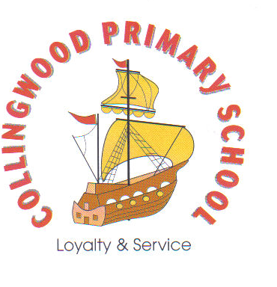
Oswin Terrace
North Shields
Tyne & Wear
NE29 7JQ
Tel (0191) 6053378
Email: collingwood.schooloffice@collingwoodprimary.org.uk
Website: www.collingwoodprimary.org
Re: Pupil Premium Funding
https://my.northtyneside.gov.uk/category/238/free-school-meals
Dear Parent/guardian.
Benefits of applying for Pupil Premium:
- Free school milk
- Grocery vouchers during the school holidays
- Free school trips
- Discounted residential trips
- Uniform vouchers

Although all children in Reception, Year 1 and Year 2 are entitled to the similarly named “Universal Infant Free School Meals” (UIFSM), this does not attract any funding for school. It also does not make them eligible to receive vouchers in the school holidays or free milk.
We would like all parents and carers of children in Reception, Year 1 and Year 2 to apply.
We are going to hold drop in sessions to support with this. The application is very straight forward and will only take a few minutes of your time. Please bring your National Insurance number.
Drop in sessions
- Every morning this week from 8.45am at Reception and KS1 entrances
- After school every day this week from 3.10pm at Reception and KS1 entrances

Thank you,

Mrs Wordsworth
School Business Manager

